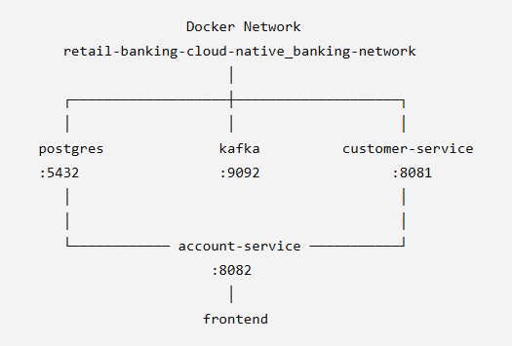

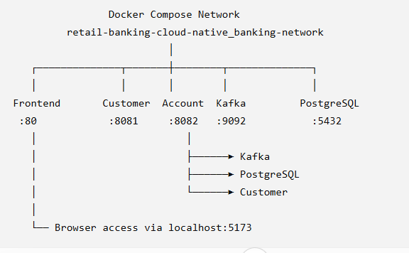

Troubleshooting commands
Test Docker DNS
- docker exec customer-service getent hosts postgres
To check the internal DNS
- docker exec customer-service getent hosts account-service
Force recreate
- docker compose up -d --force-recreate customer-service

Inspect the network
docker network inspect retail-banking-cloud-native_banking-network

docker exec kafka kafka-topics --bootstrap-server kafka:9092 –list
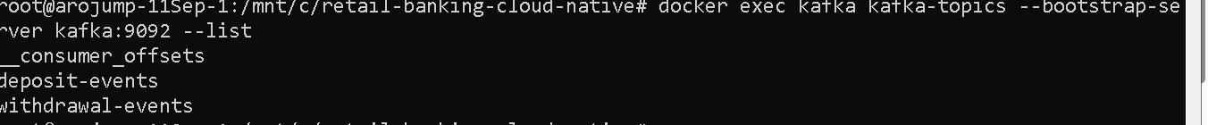

docker exec -it kafka kafka-console-producer \
--bootstrap-server kafka:9092 \
--topic account-events
>Test message

To delete the old network
docker network rm banking-network

To see the kafka working
docker logs -f account-service
in one window
and login to other window and perform the deposit and withdrawal workflow

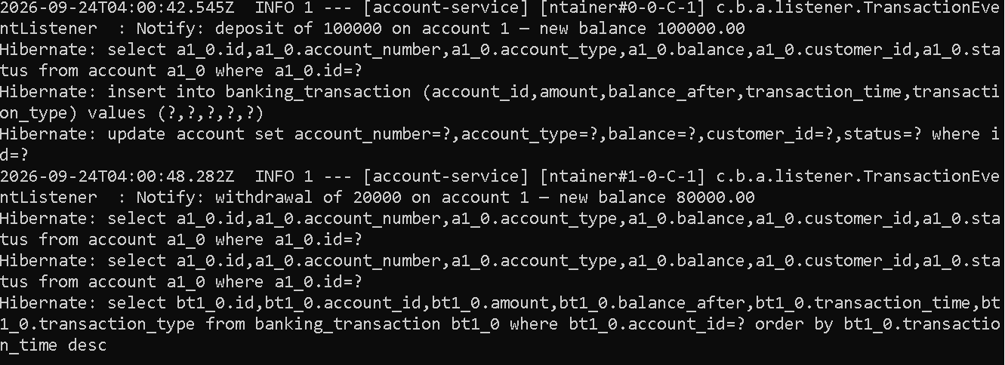

App-services.yml file for deployment
# ============================================================
# RETAIL BANKING - COMPLETE AKS DEPLOYMENT
# ============================================================

# ============================================================
# 1. NAMESPACE
# ============================================================
apiVersion: v1
kind: Namespace
metadata:
name: retail-banking

---
# ============================================================
# 2. POSTGRESQL DEPLOYMENT
# ============================================================
apiVersion: apps/v1
kind: Deployment
metadata:
name: postgres
namespace: retail-banking
spec:
replicas: 1

selector:
matchLabels:
app: postgres

template:
metadata:
labels:
app: postgres

spec:
containers:
- name: postgres
image: postgres:16-alpine

ports:
- containerPort: 5432

env:
- name: POSTGRES_USER
valueFrom:
secretKeyRef:
name: app-secret
key: DB_USERNAME

- name: POSTGRES_PASSWORD
valueFrom:
secretKeyRef:
name: app-secret
key: DB_PASSWORD

volumeMounts:
- name: postgres-init
mountPath: /docker-entrypoint-initdb.d

volumes:
- name: postgres-init
configMap:
name: postgres-init-script

---
# ============================================================
# 3. POSTGRESQL SERVICE
# ============================================================
apiVersion: v1
kind: Service
metadata:
name: postgres
namespace: retail-banking

spec:
type: ClusterIP

ports:
- port: 5432
targetPort: 5432

selector:
app: postgres

---
# ============================================================
# 4. KAFKA DEPLOYMENT
# ============================================================
apiVersion: apps/v1
kind: Deployment
metadata:
name: kafka
namespace: retail-banking

spec:
replicas: 1

selector:
matchLabels:
app: kafka

template:
metadata:
labels:
app: kafka

spec:
containers:
- name: kafka
image: confluentinc/cp-kafka:7.6.0

ports:
- containerPort: 9092
- containerPort: 9093

env:
# KRaft node configuration
- name: KAFKA_NODE_ID
value: "1"

- name: KAFKA_PROCESS_ROLES
value: "broker,controller"

- name: KAFKA_CONTROLLER_QUORUM_VOTERS
value: "1@kafka:9093"

- name: KAFKA_CONTROLLER_LISTENER_NAMES
value: "CONTROLLER"

# Listeners
- name: KAFKA_LISTENERS
value: "INTERNAL://0.0.0.0:9092,CONTROLLER://0.0.0.0:9093"

- name: KAFKA_ADVERTISED_LISTENERS
value: "INTERNAL://kafka:9092"

- name: KAFKA_LISTENER_SECURITY_PROTOCOL_MAP
value: "CONTROLLER:PLAINTEXT,INTERNAL:PLAINTEXT"

- name: KAFKA_INTER_BROKER_LISTENER_NAME
value: "INTERNAL"

# KRaft cluster ID
- name: CLUSTER_ID
value: "MkU3OEVBNTcwNTJENDM2Qk"

# Single-node Kafka
- name: KAFKA_OFFSETS_TOPIC_REPLICATION_FACTOR
value: "1"

- name: KAFKA_TRANSACTION_STATE_LOG_REPLICATION_FACTOR
value: "1"

- name: KAFKA_TRANSACTION_STATE_LOG_MIN_ISR
value: "1"

- name: KAFKA_LOG_DIRS
value: "/tmp/kraft-combined-logs"

readinessProbe:
tcpSocket:
port: 9092
initialDelaySeconds: 20
periodSeconds: 10
failureThreshold: 12

livenessProbe:
tcpSocket:
port: 9092
initialDelaySeconds: 30
periodSeconds: 15
failureThreshold: 5

---
# ============================================================
# 5. KAFKA SERVICE
# ============================================================
apiVersion: v1
kind: Service
metadata:
name: kafka
namespace: retail-banking

spec:
type: ClusterIP

ports:
- name: kafka
port: 9092
targetPort: 9092

selector:
app: kafka

---
# ============================================================
# 6. ACCOUNT SERVICE DEPLOYMENT
# ============================================================
apiVersion: apps/v1
kind: Deployment
metadata:
name: account-service
namespace: retail-banking

spec:
replicas: 1

selector:
matchLabels:
app: account-service

template:
metadata:
labels:
app: account-service

spec:
containers:
- name: account-service

# NEW IMAGE AFTER KAFKA INTEGRATION
image: solo01akslab.azurecr.io/account-service:t01-v2

ports:
- containerPort: 8082

env:
# ------------------------------------------------
# DATABASE
# ------------------------------------------------
- name: DB_URL
value: "jdbc:postgresql://postgres.retail-banking.svc.cluster.local:5432/account_db"

- name: DB_USERNAME
valueFrom:
secretKeyRef:
name: app-secret
key: DB_USERNAME

- name: DB_PASSWORD
valueFrom:
secretKeyRef:
name: app-secret
key: DB_PASSWORD

# ------------------------------------------------
# CUSTOMER SERVICE
# ------------------------------------------------
- name: CUSTOMER_SERVICE_URL
value: "http://customer-service:8081"

# ------------------------------------------------
# KAFKA
# ------------------------------------------------
- name: KAFKA_BOOTSTRAP_SERVERS
value: "kafka:9092"

resources:
requests:
memory: "256Mi"
cpu: "250m"

limits:
memory: "512Mi"
cpu: "500m"

startupProbe:
tcpSocket:
port: 8082
initialDelaySeconds: 20
periodSeconds: 10
failureThreshold: 12

readinessProbe:
tcpSocket:
port: 8082
initialDelaySeconds: 10
periodSeconds: 10
failureThreshold: 6

livenessProbe:
tcpSocket:
port: 8082
initialDelaySeconds: 30
periodSeconds: 15
failureThreshold: 5

---
# ============================================================
# 7. ACCOUNT SERVICE
# ============================================================
apiVersion: v1
kind: Service
metadata:
name: account-service
namespace: retail-banking

spec:
type: ClusterIP

ports:
- port: 8082
targetPort: 8082

selector:
app: account-service

---
# ============================================================
# 8. CUSTOMER SERVICE DEPLOYMENT
# ============================================================
apiVersion: apps/v1
kind: Deployment
metadata:
name: customer-service
namespace: retail-banking

spec:
replicas: 1

selector:
matchLabels:
app: customer-service

template:
metadata:
labels:
app: customer-service

spec:
containers:
- name: customer-service

# NEW IMAGE
image: solo01akslab.azurecr.io/customer-service:t01-v2

ports:
- containerPort: 8081

env:
# ------------------------------------------------
# DATABASE
# ------------------------------------------------
- name: DB_URL
value: "jdbc:postgresql://postgres.retail-banking.svc.cluster.local:5432/customer_db"

- name: DB_USERNAME
valueFrom:
secretKeyRef:
name: app-secret
key: DB_USERNAME

- name: DB_PASSWORD
valueFrom:
secretKeyRef:
name: app-secret
key: DB_PASSWORD

resources:
requests:
memory: "256Mi"
cpu: "250m"

limits:
memory: "512Mi"
cpu: "500m"

startupProbe:
tcpSocket:
port: 8081
initialDelaySeconds: 20
periodSeconds: 10
failureThreshold: 12

readinessProbe:
tcpSocket:
port: 8081
initialDelaySeconds: 10
periodSeconds: 10
failureThreshold: 6

livenessProbe:
tcpSocket:
port: 8081
initialDelaySeconds: 30
periodSeconds: 15
failureThreshold: 5

---
# ============================================================
# 9. CUSTOMER SERVICE
# ============================================================
apiVersion: v1
kind: Service
metadata:
name: customer-service
namespace: retail-banking

spec:
type: ClusterIP

ports:
- port: 8081
targetPort: 8081

selector:
app: customer-service

---
# ============================================================
# 10. FRONTEND DEPLOYMENT
# ============================================================
apiVersion: apps/v1
kind: Deployment
metadata:
name: frontend
namespace: retail-banking

spec:
replicas: 1

selector:
matchLabels:
app: frontend

template:
metadata:
labels:
app: frontend

spec:
containers:
- name: frontend

# EXISTING FRONTEND IMAGE
image: solo01akslab.azurecr.io/frontend:t01-v1

ports:
- containerPort: 80

resources:
requests:
memory: "64Mi"
cpu: "100m"

limits:
memory: "128Mi"
cpu: "250m"

---
# ============================================================
# 11. FRONTEND LOAD BALANCER SERVICE
# ============================================================
apiVersion: v1
kind: Service
metadata:
name: frontend
namespace: retail-banking

spec:
type: LoadBalancer

ports:
- port: 80
targetPort: 80

selector:
app: frontend

